

Zainaaz Hansa & Nombulelo Ndlovu

Detailed Analysis

Case Study 4:

# Table of Contents

Table of Contents 2

Case Study Given 3

Background Research 3

NZÉRÉKORÉ, GUINEA 3

Simandou Iron Ore Project in Guinea 5

Rio Tinto's commitment to Simandou 5

Problem statement 5

Challenges faced by the Community 6

Rio Tinto's Objectives 7

Community Programs 7

Strategy 7

Programs to tackle problems 7

Constraints 14

Research Questions 17

Proposed Schedule 17

Gantt Chart 17

Overlapping of programs 18

Tracking Analytics 19

Establishing a System for Tracking the Impact of Community Initiatives 19

Steps 19

What we intend on tracking: 21

Tracking System Overview 23

# Case Study Given

**CASE STUDY 4: Community Development and Local Investment Strategy**

**Current Situation:**

The mining company’s involvement in local socioeconomic development is limited. There is little support for education, skills training, or job creation, resulting in weak connections with the community and limited local economic growth.

**Target Objective:**

Create a community investment strategy that strengthens local ties and supports sustainable development. The strategy should:

* Conduct a needs assessment to identify community priorities, such as education or infrastructure improvements. Highlight what a good needs assessment is and how this will look like. [research Simandou as per the target area]
* Develop programs for job creation and skills training **that align with local needs and available resources.**
* Establish a system for tracking **the impact of community initiatives** to ensure long-term benefits.

Teams should aim to design a sustainable plan that positions the company as a valuable partner in local economic development.

# Background Research

## NZÉRÉKORÉ, GUINEA

* Nzérékoré is Guinea's second-largest city and a key commercial and economic hub in the southeastern region.
* The city is culturally diverse, with various ethnic groups contributing to a rich blend of traditions and languages.
* The local economy is primarily driven by agriculture, commerce, handicrafts, and small to medium-sized enterprises.
* Road infrastructure is underdeveloped, with many unpaved roads that are difficult to navigate, especially during the rainy season, hindering transportation and trade.
* Nzérékoré has benefited from the CLSG interconnection project, which has improved electricity supply for residents and businesses.
* Other infrastructure, such as healthcare, education, and sanitation, still requires significant development to meet population demands.
* Despite challenges, Nzérékoré remains a vibrant cultural and economic center in the region.

**Demographics:**

* **Population Size:** The Nzérékoré Region has an estimated population of approximately 1.9 million people. [City Facts](https://www.city-facts.com/nzerekore/population?utm_source=chatgpt.com)
* **Age Distribution:** The median age in the region is 16.1 years, indicating a youthful population. [City Facts](https://www.city-facts.com/nzerekore/population?utm_source=chatgpt.com)
* **Gender Ratios:** The population comprises about 48.2% males and 51.8% females. [City Facts](https://www.city-facts.com/nzerekore/population?utm_source=chatgpt.com)

**Employment and Economy:**

* **Dominant Industries:** Agriculture is the primary source of employment, with significant activities in commerce, handicrafts, and small to medium-sized enterprises. [UIL](https://www.uil.unesco.org/en/learning-cities/nzerekore?utm_source=chatgpt.com)
* **Income Levels:** Specific income data is limited; however, the region's economic activities suggest a reliance on subsistence agriculture and small-scale trade.

**Education and Skills:**

* **Literacy Rates:** Detailed literacy statistics are not readily available, but educational infrastructure investments, such as the construction of 18 classrooms, indicate efforts to improve literacy. [UIL](https://www.uil.unesco.org/en/learning-cities/nzerekore?utm_source=chatgpt.com)
* **School Attendance:** The region has undertaken initiatives to enhance educational participation, including plans to build 100 classrooms and two vocational training centers. [UIL](https://www.uil.unesco.org/en/learning-cities/nzerekore?utm_source=chatgpt.com)
* **Vocational Training Availability:** There are plans to establish vocational training centers to equip residents with practical skills. [UIL](https://www.uil.unesco.org/en/learning-cities/nzerekore?utm_source=chatgpt.com)

**Healthcare Access:**

* **Healthcare Facilities:** The region has invested in healthcare by constructing and equipping health centers. [UIL](https://www.uil.unesco.org/en/learning-cities/nzerekore?utm_source=chatgpt.com)
* **Quality of Care:** Efforts to combat diseases like COVID-19 and Ebola have included distributing health kits to the population. [UIL](https://www.uil.unesco.org/en/learning-cities/nzerekore?utm_source=chatgpt.com)

**Infrastructure:**

* **Access to Clean Water:** The region has implemented sanitation actions, including waste collection and transformation, to improve environmental sustainability. [UIL](https://www.uil.unesco.org/en/learning-cities/nzerekore?utm_source=chatgpt.com)
* **Electricity:** Specific data on electricity access is limited, but infrastructure development is ongoing.
* **Transport:** The region's infrastructure includes roads connecting key areas, with ongoing projects to enhance transportation links.

## Simandou Iron Ore Project in Guinea

the mine is located in the Simandou mountain range of southern Guinea's Nzérékoré Region

**Simandou's Potential:** The project is transformative, offering infrastructure development, thousands of jobs, and economic opportunities that will benefit Guinea for generations.

The Simandou iron ore project in Guinea is estimated to cost around $11.6 billion, with Rio Tinto's share being approximately $6.2 billion, with $5.7 billion remaining to be spent as of January 1, 2024. Simandou’s development includes constructing railways, ports, and other necessary facilities.

## Rio Tinto's commitment to Simandou

* **Commitment to Sustainability:** Rio Tinto is focused on minimizing social, health, safety, and environmental impacts while fostering positive changes for local communities and stakeholders.
* **Long-Term Stewardship:** Rio Tinto views itself as a steward of natural resources and is dedicated to environmental stewardship and social wellbeing in developing the Simandou project.
* **Community Engagement:** Regular community consultation forums and sessions are held to address local concerns, maintain dialogue, and explore additional support opportunities.

# Problem statement

Rio Tinto’s involvement in local socioeconomic development in the Simandou Project is limited. There is:

1. Limited support for education
2. No focus on job creation
3. Not much skill training

This disconnect has resulted in weak community engagements and minimal contribution to local economic growth.

"The long-run social impact would be surprisingly small without an active policy. The MIMMI model shows that the project would reduce the poverty rate only by 0.6 percentage points and the poverty depth (distance by which households fall below the poverty line) by 0.9 percentage points in. At the same time, the project could even lead to worsening of inequality, especially in rural areas, as the Gini index, a measure of inequality, could increase. This result is explained by increasing salaries of the most skilled workers, as mining companies increase the demand for skilled labour."

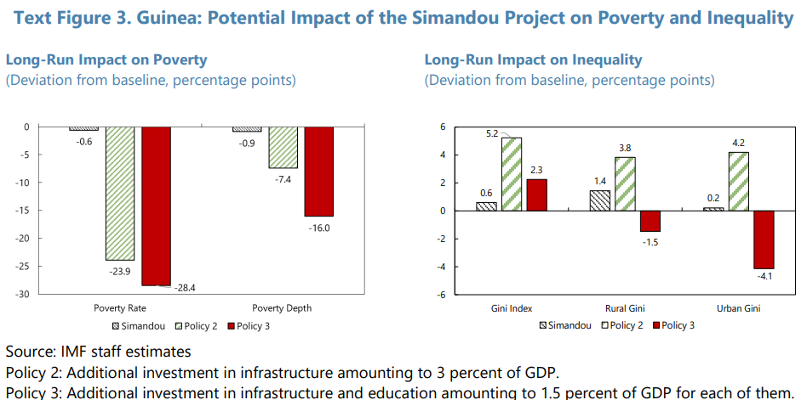

### Challenges faced by the Community

**Poverty and Inequality**:

* 43% of Guinean households live below the poverty line, with rural areas, women, and those without education being disproportionately affected.
* Income inequality is stark, with the richest 10% earning 42% of total income while the bottom 50% earn only 17%.

**Limited Access to Education**:

* Guinea has low public spending on education compared to Sub-Saharan and other low-income countries, contributing to a lack of educational opportunities and perpetuating inequality.

**Economic Dependence on Mining**:

* The economy is heavily reliant on mining, which accounts for 21% of GDP and over 90% of exports, making it vulnerable to fluctuations in global commodity prices.

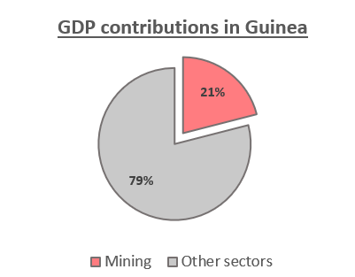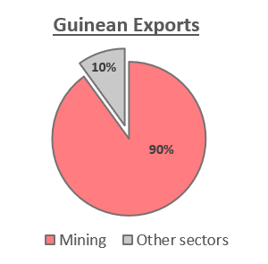

### Rio Tinto's Objectives

Focusing on low-tech, culturally sensitive outreach methods will ensure meaningful engagement with the communities surrounding the Simandou project.

Enhance the mines leadership ability and decision making

1. Develop a comprehensive community investment strategy that prioritises education, skills training, and job creation.
2. Conduct a participatory needs assessment to identify community priorities and align initiatives with local needs.
3. Establish systems to monitor and evaluate the impact of community development programs.
4. Position Rio Tinto as a long-term partner in Nzérékoré’s economic growth and development.

# Community Programs

## Strategy

Agile Methodology for Needs Assessment

* **Frameworks:**
  + Scrum: Needs assessment in sprints.
  + Kanban: Visual tracking of tasks.
* **Data Collection Tools:**
  + Research and feasibility studies.

IMF’s Multi-Sector Macro-Inequality Model (MIMMI) helps us to analyse the impact on poverty and inequality over the long term.

## Programs to tackle problems

**The order that these programs are vital to the strategy:**

1. Build Immediate Trust: Start with visible and impactful projects like roads and water systems.
2. Empower and Educate: Progressively engage the community through workshops and training.
3. Develop Long-term Sustainability: Conclude with programs that create lasting economic and educational opportunities.

These programs are aimed at community engagement, local economic growth, job creation and skills training.

#### Program 1: Road and Bridge Construction

Aim: Build trust. Do something first thats very visible so that can see things are being done already so its easier for the transition to the next program.

Transport**:** The region's infrastructure includes roads connecting key areas, with ongoing projects to enhance transportation links.

* Conduct feasibility studies for local infrastructure projects.
* Hire and train community members in construction skills.
* Partner with contractors to prioritize local hiring.

**Resources Needed**

* Construction equipment and tools.
* Technical experts for on-the-job training.

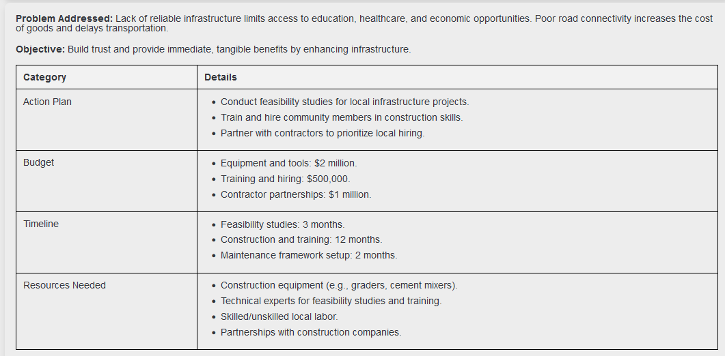

#### Program 2: Water and Sanitation Projects

* Identify communities with critical water and sanitation needs.
* Train locals in plumbing, construction of boreholes, and sanitation systems.
* Partner with NGOs and government bodies for funding and technical expertise.

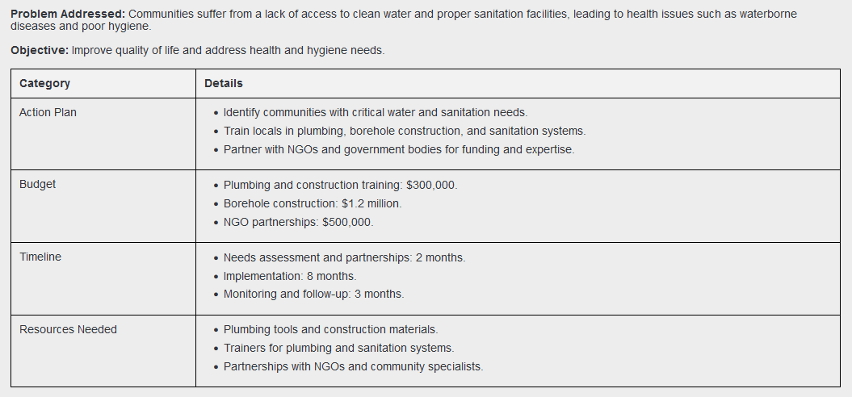

#### Program 3: Leadership, Trust and Confidence Workshop(s)

Cultural and linguistic diversity requiring tailored communication strategies. What is the culture like there - are they open to women being in STEM? Uneducated people arent aware how much the mine actually contributes to the economy, but they dont know better other than all the negatives (pollution etc) so they may have negative impressions of the mines.

Historically, girls in Guinea have faced significant barriers to education, including deep-rooted cultural traditions that often prioritize domestic roles over formal education. Between 2008 and 2012, nearly 36% of teenage girls were married, reflecting societal norms that can impede educational attainment - you want to build up their confidence.

* Organize workshops on leadership, communication, and decision-making.
* Partner with women's organizations to ensure accessibility and inclusivity.
* Provide training in public speaking and financial literacy.

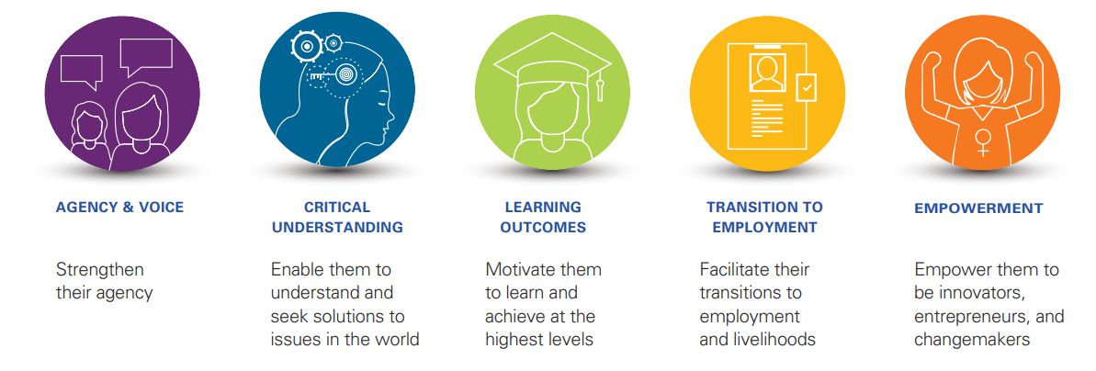

Resources needed: marketing the workshop - making sure people want to attend.. Target to girls and youth etc

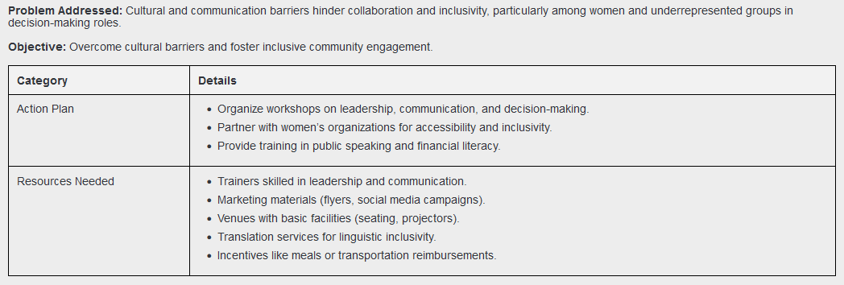

#### Program 4: Youth Empowerment: Scholarships and Sponsorships and Internships within the Mining Company

Why? Age Distribution: The median age in the region is 16.1 years, indicating a youthful population. [City Facts](https://www.city-facts.com/nzerekore/population?utm_source=chatgpt.com)

this will be mentioned at the workshops in the previous programs

* Create a scholarship fund for students in STEM, mining, or technical fields.
* Collaborate with local schools and colleges to identify high-potential students.
* Offer additional mentorship and support for scholarship recipients.
* Develop internship roles across departments (e.g., operations, safety, maintenance).
* Work with educational institutions to align internships with curricula.
* Create a mentorship framework where employees guide interns.
* Provide apprenticeship opportunities within the Simandou project.

**Resources Needed**

* Training materials.
* Funding for stipends or allowances.
* Collaboration with local chambers of commerce and trade associations.

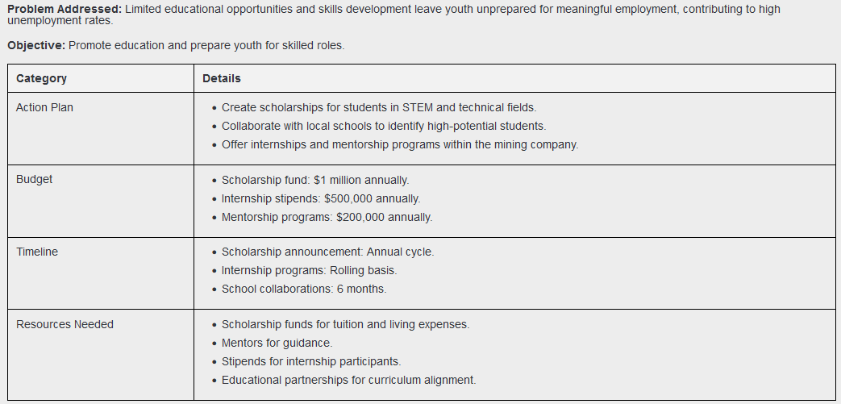

#### Program 5:  Access to Markets and Financing

Given the industrial scale and export-oriented nature of the Simandou project, it is uncommon for individual residents to purchase products or by-products directly from the mine. The operations are structured to supply bulk raw materials to international markets, primarily for steel production. BUT STRUCTURES COULD BE PUT INTO PLACE FOR THE SALE OF BY-PRODUCTS to residents.

Why?

* A diversified economy can absorb external shocks better, reducing Guinea’s exposure to risks from mining sector fluctuations.
* could enable the country to make significant progress in its diversification process and raise the productivity and share of the non-mining sectors.
* Sectors like small-scale manufacturing, trade, and tourism can absorb more unskilled and semi-skilled labor than mining can.
* Increased local economic activity encourages investment in infrastructure, which supports other sectors.

Example of residents using by products:

Use iron ore dust or sand to create:

* Decorative Home and Garden Items:
* Garden stepping stones with artistic imprints.
* Handmade flower pots or garden borders.
* Market: Homeowners looking for aesthetic improvements.
* Unique Selling Point: Unique designs and handmade quality.

Slag or polished small stone

* Jewelry or Artifacts
* Product: Use slag or polished small stones to craft handmade jewelry, such as necklaces, bracelets, or decorative artifacts.
* Market: Tourists, local markets, or cultural enthusiasts.
* Unique Selling Point: Authentic Guinean crafts made from local materials.

As of January 2024, Guinea had approximately 4.87 million internet users, representing an internet penetration rate of 33.9% of the total population. [Datareportal](https://datareportal.com/reports/digital-2024-guinea?utm_source=chatgpt.com)

* Establish a microfinance fund to support women-led enterprises.
* Conduct market linkages workshops to help entrepreneurs connect with buyers.
* Partner with local banks to simplify access to credit.
* Build an app for local customers who have bought by products from the mine and turned it into something meaningful so they can advertise the product on the app (like a facebook marketplace) but promoting and advertising will be done by Rio Tinto

Resources needed:

* Trainers for workshops.
* Funding for microfinance programs.
* App

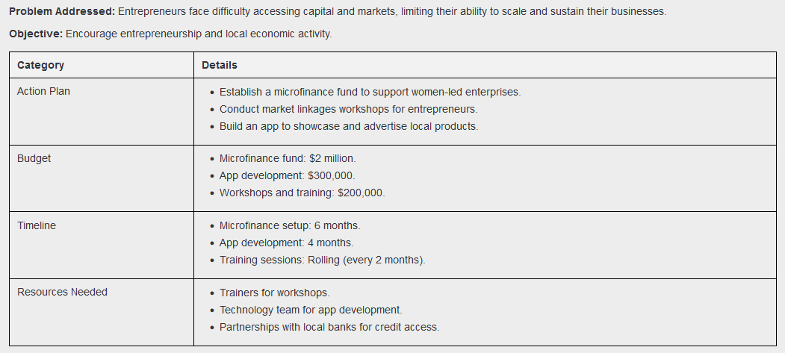

#### Program 6: Technical Schools

Why?

The country has low public spending on education and is one of the most illiterate countries in the world.

* Sponsor the creation of new courses aligned with industry needs (e.g., mining safety, machine operation).

educational infrastructure investments, such as the construction of 18 classrooms, indicate efforts to improve literacy. [UIL](https://www.uil.unesco.org/en/learning-cities/nzerekore?utm_source=chatgpt.com). The region has undertaken initiatives to enhance educational participation, including plans to build 100 classrooms and two vocational training centers. [UIL](https://www.uil.unesco.org/en/learning-cities/nzerekore?utm_source=chatgpt.com). There are plans to establish vocational training centers to equip residents with practical skills.[UIL](https://www.uil.unesco.org/en/learning-cities/nzerekore?utm_source=chatgpt.com)

INVEST IN THESE UPCOMING PROJECTS!!!!

This graph underscores the need for more effective use of educational resources in Guinea, with a focus on expanding teacher training, classroom capacity, and infrastructure to address overcrowding and improve education quality.

investment in infrastructure and education would be beneficial both for reducing inequality and the long-term growth of the economy. Education increases labour productivity and, thus, incomes. Among others, the authorities could target measures to promote girls' education. School canteen programs, one of the FSW-funded interventions, could also be continued and made permanent. In addition, well-targeted spending on social protection, such as investments in social services and health care, are not part of our model but would also help to improve standards of living.

**Resources Needed**

* Scholarships budget.
* Partnerships with educational institutions.
* Curriculum development experts.

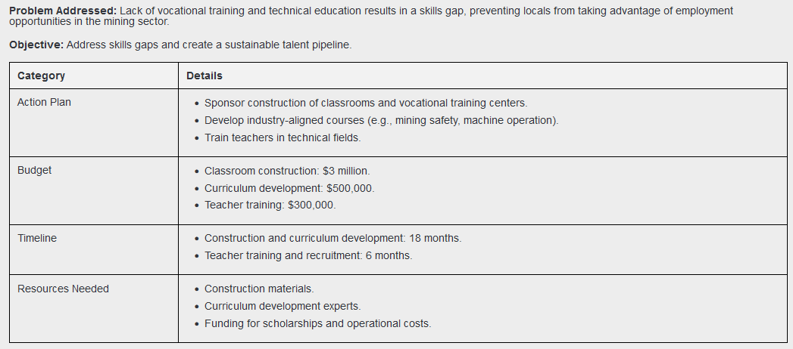

#### Program 7: Partner with Local Businesses

* Identify local businesses in sectors such as construction, logistics, and services.
* Negotiate formal agreements for apprenticeship placements.
* Offer subsidies or incentives to businesses hosting apprentices.

Develop programs to source goods and services from local businesses, offering contracts for construction, catering, and maintenance.

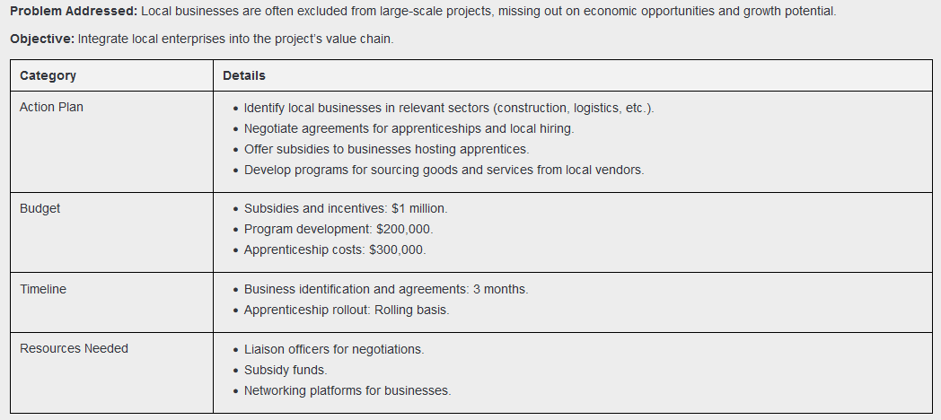

## Constraints

**Financial Constraints**

* Issue:
  + Limited budget for community investment initiatives restricts the scope and scale of projects.
  + Competing priorities between infrastructure development and social programs.
* Impact:
  + May delay or reduce the quality of construction (roads, schools).
  + Affects the ability to provide stipends, scholarships, or loans.
* Mitigation:
  + Seek partnerships with NGOs, government bodies, and international organizations for co-funding.
  + Implement cost-sharing mechanisms with local stakeholders.

**Social Constraints**

* Cultural and Linguistic Diversity:
  + Guinea’s diverse ethnic groups and languages require tailored communication strategies.
  + Historical gender norms may restrict women's participation in leadership and technical training.
* Community Perceptions:
  + Negative impressions of mining activities (e.g., pollution) may lead to resistance.
* Impact:
  + Hinders participation in programs like leadership workshops or market linkages.
  + Requires additional resources for cultural adaptation.
* Mitigation:
  + Involve community leaders early to build trust.
  + Use culturally sensitive materials and provide interpretation services during events.
  + Highlight immediate benefits (e.g., job creation, infrastructure improvements) to shift perceptions.

**Time Constraints**

* Issue:
  + Tight project timelines limit long-term planning and community consultation.
  + Legal disputes and political changes have already caused delays in the Simandou project.
* Impact:
  + Programs may be rushed, reducing their quality and effectiveness.
  + Delays in infrastructure completion can undermine trust in the company.
* Mitigation:
  + Use phased implementation with clear milestones to show incremental progress.
  + Prioritize quick-win projects (e.g., road repairs) to demonstrate action.

**Infrastructure Challenges**

* Issue:
  + Underdeveloped roads and transport links complicate logistics and access.
  + Electricity supply is unreliable, affecting workshops and vocational training.
* Impact:
  + Delays in material delivery and training sessions.
  + Limits scalability of technology-based programs like the app for market linkages.
* Mitigation:
  + Schedule programs during seasons with better road conditions.
  + Invest in temporary infrastructure (e.g., portable generators) for critical programs.

**Human Resource Constraints**

* Issue:
  + Limited availability of skilled trainers, facilitators, and technical experts.
  + Dependence on external contractors for specialized tasks.
* Impact:
  + Increases costs due to reliance on outside experts.
  + Slows down knowledge transfer to the local community.
* Mitigation:
  + Train local trainers to reduce dependence on external resources.
  + Establish partnerships with universities or vocational institutions to build capacity.

**Environmental Constraints**

* Issue:
  + Programs like road construction may face disruptions due to Guinea’s heavy rainy seasons.
  + Mining activities contribute to environmental degradation, which may fuel local opposition.
* Impact:
  + Delays in construction and other outdoor programs.
  + Challenges in maintaining environmental sustainability in project execution.
* Mitigation:
  + Plan construction schedules around seasonal weather patterns.
  + Implement and communicate environmental safeguards to the community.

**Political and Legal Constraints**

* Issue:
  + Local political changes or disputes can delay decision-making and approvals.
  + Legal challenges regarding land use or labor laws may arise.
* Impact:
  + Slows down program rollouts, particularly infrastructure and vocational training initiatives.
  + May create uncertainty about long-term project viability.
* Mitigation:
  + Engage with local and national government representatives to ensure alignment with policies.
  + Proactively address legal issues by consulting with experts.

**Technological Constraints**

* Issue:
  + Low internet penetration (33.9% as of January 2024) limits access to online platforms like the proposed app for market linkages.
  + Limited technological infrastructure in rural areas.
* Impact:
  + Reduces the reach of digital solutions like microfinance apps or educational programs.
  + Increases costs for setting up necessary infrastructure.
* Mitigation:
  + Combine online and offline approaches (e.g., SMS-based updates).
  + Partner with telecom providers to expand coverage in target areas.

## Research Questions

Understanding the Community

* What are the priority needs of the Nzérékoré community, and how can Rio Tinto address them effectively?
* How does the demographic profile (e.g., age distribution, gender ratios, literacy levels) influence program design and implementation?
* What cultural and linguistic considerations must be accounted for to ensure successful community engagement?

Building Community Relationships

* What strategies can Rio Tinto employ to strengthen community engagement and foster trust?
* How can the company effectively address negative perceptions of the mining industry within the community?
* Why is it important to build strong connections with the community, particularly as a mining business?

Designing Effective Programs

* How can the company design and implement sustainable programs for education, skills training, and job creation?
* Which existing local resources and infrastructures can be leveraged to reduce costs and enhance program effectiveness?
* How can programs like scholarships, technical schools, and market linkages be aligned with local economic and educational goals?

Evaluating Impact and Sustainability

* What are the best practices from other mining projects for community investment and development?
* What metrics should be used to track the social, economic, and environmental impact of these programs?
* How can Rio Tinto ensure that the benefits of its community investment programs are sustained beyond the project’s lifecycle?

Assessing Constraints and Risks

* Was there enough capital invested in the project to achieve meaningful community engagement?
* How can Rio Tinto address constraints such as limited budget, time, and infrastructure effectively?
* What potential risks (e.g., political instability, environmental degradation) could jeopardize the success of the community programs?

## Proposed Schedule

### Gantt Chart

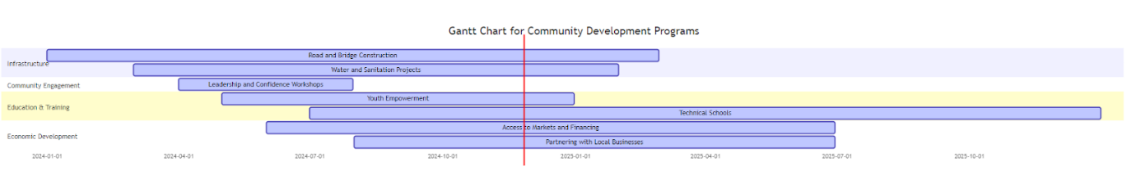

Expected completion date: December 31, 2025

### Overlapping of programs

**1. Road and Bridge Construction + Partnering with Local Businesses**

**Overlap Opportunity:**

* Local businesses can be contracted for construction materials, equipment supply, or workforce provision.
* Apprenticeships or training programs can be integrated into the construction phase, providing hands-on experience.

**Benefit:** Encourages local economic activity while addressing infrastructure needs.

**2. Leadership, Trust, and Confidence Workshops + Youth Empowerment**

**Overlap Opportunity:**

* Workshops can include information on scholarships, internships, and mentorship opportunities.
* Leadership training can be tailored for scholarship recipients or youth groups, preparing them for future roles.

**Benefit:** Builds confidence in young people while guiding them toward available programs.

**3. Access to Markets and Financing + Partnering with Local Businesses**

**Overlap Opportunity**:

* Microfinance initiatives can directly target small businesses that are part of the apprenticeship or supply chain programs.
* Market linkage workshops can incorporate partnerships with businesses supported by other initiatives.

**Benefit:** Strengthens local businesses while fostering job creation and economic independence.

**4. Technical Schools + Youth Empowerment**

**Overlap Opportunity:**

* Scholarships can prioritize students pursuing technical school programs.
* Internship and apprenticeship roles can be aligned with technical school curricula, ensuring practical application of learned skills.

**Benefit:** Creates a pipeline of skilled workers ready to integrate into the workforce.

**5. Water and Sanitation Projects + Leadership Workshops**

**Overlap Opportunity:**

* Leadership workshops can include training for community members who will manage water and sanitation projects.
* These workshops can also involve educating women on managing sanitation systems, fostering inclusivity.

**Benefit**: Empowers communities to take ownership of basic infrastructure while building leadership.

**6. Access to Markets and Financing + Youth Empowerment**

**Overlap Opportunity:**

* Youth-led businesses can benefit from microfinance and app-based market access.
* Internships can include roles related to marketing or app management for small businesses.

**Benefit:** Encourages entrepreneurial activity among the youth and links them to financial and market resources.

# Tracking Analytics

## Establishing a System for Tracking the Impact of Community Initiatives

### Steps

1. Define objectives and KPIs to measure success, focusing on outcomes like employment, literacy, or healthcare access. Develop measurable indicators such as jobs created, school enrollment increases, and health service improvements.
2. Conduct a baseline assessment by collecting pre-initiative data through surveys and interviews, focusing on key areas like education, employment, and income. Document findings in a baseline report.
3. Develop a data collection framework, deciding on the frequency and methods like surveys, focus groups, observations, or case studies. Integrate technology such as mobile apps and GIS for real-time data collection.
4. Establish monitoring and evaluation teams comprising company representatives, community members, and third-party evaluators to collect and analyze data, prepare reports, and ensure transparency.
5. Use digital tools like dashboards (Power BI, Tableau) for data visualization, project management software (Asana, Trello) for progress tracking, and mobile apps for community feedback and issue reporting.
6. Involve stakeholders by sharing regular updates, creating feedback channels, and hosting public forums to discuss results and gather insights.
7. Conduct independent audits annually or at major milestones to evaluate resource use and goal achievement. Publish findings to build trust and credibility.
8. Adapt initiatives based on data analysis, refining programs to address challenges and expand successful efforts to new areas.
9. Conduct long-term impact studies to evaluate sustained benefits, tracking metrics over time and comparing impacted with non-impacted communities.
10. Communicate findings effectively to stakeholders through reports and updates, ensuring transparency and fostering accountability.

Implementing a robust monitoring and evaluation (M&E) system ensures that community initiatives deliver long-term benefits and allows for continuous improvement.

**Components of an Effective M&E System:**

* Set Clear Objectives: Define specific, measurable goals for each initiative.
* Develop Key Performance Indicators (KPIs): Identify metrics to assess progress toward objectives.
* Regular Data Collection: Establish processes for consistent data gathering and analysis.
* Community Feedback Mechanisms: Create channels for community members to provide input and share experiences.
* Reporting and Transparency: Share findings with stakeholders and use insights to refine and enhance programs.
* Automation of Insights: Use automated tools to generate graphs and dashboards to visualize program performance.

**Monitoring and Evaluation Metrics:**

* Number of participants trained and employed.
* Community satisfaction levels through surveys.
* Increase in local business revenue or household income.
* Progress against timelines and milestones for infrastructure projects.

**Tools:**

* Regular Field Reports: Ensure on-ground data collection and insights.
* Feedback Mechanisms: Use mobile apps or community meetings to collect real-time input.
* Power BI Analytical Tools: Automate data visualization, track program metrics, and provide dynamic dashboards for stakeholders.
* AI-Driven Strategies: Implement AI to analyze program data and recommend corrective actions if a program is behind schedule. For example, AI can suggest resource reallocations or prioritize bottleneck areas to optimize workflows.

**Frequency:**

Quarterly reviews to ensure programs meet goals, with monthly automated reporting via Power BI for real-time updates.

**Future Enhancements:**

* AI-Powered Predictions: Leverage machine learning to forecast program risks, delays, or cost overruns based on historical data.
* Dynamic Goal Adjustment: Use AI to dynamically adjust objectives and timelines based on program performance, ensuring continuous alignment with overarching community goals.

### What we intend on tracking:

**Financial Tracking**

**What to Track:**

* **Budget Utilization:** Compare the allocated budget to actual expenditures for mining operations, infrastructure, and community programs.
* **Cost Efficiency:** Assess whether the project is adhering to financial projections for specific components like railway construction, port development, and community development.
* **Funding Allocation:** Monitor the percentage of funds dedicated to different project areas (e.g., infrastructure vs. community initiatives).

**Analytics:**

* **Burn Rate Analysis:** Track how quickly the project is spending its allocated budget to detect overspending or underspending trends.
* **Cost Overrun Trends:** Use variance analysis to identify areas where costs exceed initial estimates.
* **ROI Calculations:** Measure the financial return of investments in infrastructure and community programs by analyzing productivity increases and local economic impact.

**Tools:**

* Financial dashboards using software like Power BI, Excel, or Tableau.
* Visualization: Pie charts for budget allocation, bar graphs for spending trends.

**Infrastructure Development Tracking**

**What to Track:**

* **Construction Progress:** Monitor milestones for railway and port construction (e.g., percentage of railway completed, key deadlines met).
* **Infrastructure Impact:** Assess the connectivity improvements for remote regions, such as travel time reductions and increased freight capacity.

**Analytics:**

* **Gantt Charts:** Track construction progress and project timelines.
* **Productivity Metrics:** Measure the output capacity of completed infrastructure (e.g., how many tons of iron ore can be transported daily).

**Tools:**

* Use project management tools like **Microsoft Project**, **Smartsheet**, or **Asana** to track progress.

**Community Development Initiatives**

**What to Track:**

* **Community Investments:** Amount spent on education, healthcare, job training, and other development programs.
* **Local Job Creation:** Number of jobs created directly and indirectly by the project (e.g., construction workers, mine workers).
* **Social Impact:** Improvements in literacy rates, healthcare access, and household incomes in the region.

**Analytics:**

* **Impact Assessment Reports:** Compare pre-project and post-project socioeconomic data to measure improvements.
* **Key Performance Indicators (KPIs):** Track metrics like school enrolment, healthcare visits, and job placements.
* **Geospatial Analysis:** Use GIS to map the project's reach and its benefits across different communities.

**Tools:**

* Data collection tools like SurveyMonkey, Google Forms, or mobile data collection apps.
* Geospatial tools like QGIS or ArcGIS for mapping benefits.

**Economic Impact Analysis**

**What to Track:**

* **Economic Growth in Guinea:** Measure GDP contributions from the Simandou project.
* **Local Business Involvement:** Percentage of contracts awarded to Guinean businesses.
* **Steel Production Impact:** Track how much high-quality iron ore is being supplied to the global steel industry.

**Analytics:**

* **Contribution Analysis:** Analyse the project’s role in boosting Guinea's economy.
* **Local Content Analysis:** Measure the involvement of local suppliers and service providers.
* **Export Data:** Monitor iron ore exports from Guinea after the project becomes operational.

**Tools:**

* Economic modelling tools like STATA, R, or Python.

**Environmental and Sustainability Tracking**

**What to Track:**

* **Environmental Impact:** Monitor compliance with environmental regulations, including deforestation, carbon emissions, and biodiversity preservation.
* **Sustainability Programs:** Measure the implementation of renewable energy solutions, water conservation efforts, and waste management.

**Analytics:**

* **Compliance Dashboards:** Track adherence to environmental standards and sustainability goals.
* **Carbon Footprint Analysis:** Calculate emissions during construction and mining operations.

**Tools:**

* Sustainability analytics platforms like Sphera, EcoStruxure, or in-house tools for carbon tracking.

**Risk Management**

**What to Track:**

* **Operational Risks:** Delays in railway or port construction.
* **Financial Risks:** Budget overruns and funding shortages.
* **Community Risks:** Resistance from local communities due to unmet expectations or environmental concerns.

**Analytics:**

* **Risk Heat Maps:** Visualize and rank project risks by likelihood and impact.
* **Mitigation Progress:** Track the effectiveness of risk management strategies.

**Tools:**

* Risk analysis tools like @RISK, RiskWatch, or Excel-based models.

### Tracking System Overview

A tracking dashboard for the Simandou project would look like this:

**Tabs or Sections:** Financials, Infrastructure, Community, Environment, Risks.

**Visualizations:**

* Line charts for budget trends.
* Maps for geospatial benefits.
* Bar charts for job creation and community investment.

**KPIs:**

* Budget adherence rate (%).
* % of infrastructure milestones achieved.
* % increase in local household incomes.

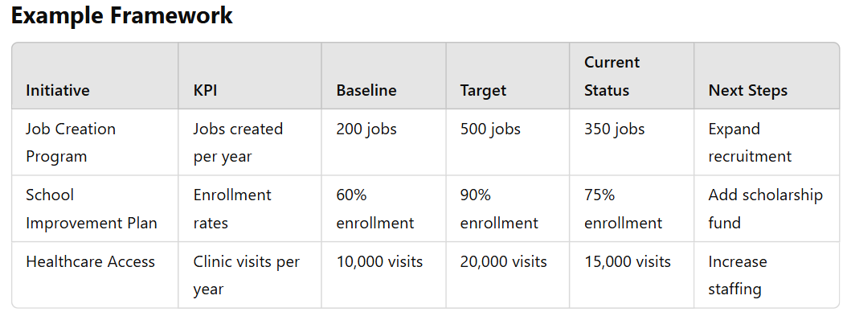**Example Framework**